Mr. Ronald G. Young

Director

Family and Employer Programs and Policy

Before the

U.S. House of Representatives

Committee on Veterans’ Affairs

Subcommittee on Economic Opportunity

Lowering the Rate of Unemployment for the National Guard and Reserve – Are We Making Progress?

March 14, 2013

10:00 AM

Room 334 – Cannon House Office Building

FOR OFFICIAL USE ONLY

UNTIL RELEASED BY THE

COMMITTEE ON VETERANS’ AFFAIRS

SUBCOMMITTEE ON ECONOMIC OPPORTUNITY

Ronald G. Young
Director
Family and Employer Programs and Policy

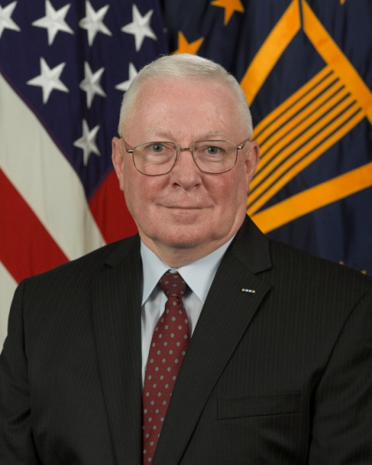
Director Ron Young is a career Senior Executive Service member hired into his position on June 7, 2010. Mr. Young is the principal staff advisor to the Assistant Secretary of Defense for Reserve Affairs on all matters involving Employer Support of the Guard and Reserve, Yellow Ribbon Reintegration Program, and Individual and Family Support Programs for the 1.2 million members in the Reserve Components of the United States Armed Forces.

Mr. Young is a graduate of Capital University with a Bachelor of Arts Degree in Public Administration and he earned a Juris Doctor from Capital University Law School. During his law school studies, Mr. Young spent one summer studying in Innsbruck, Austria, taking classes from Chief Justice Rehnquist of the U.S. Supreme Court. Mr. Young is currently an inactive member of the Ohio Bar.

Major General Young began his military service in January 1966, as a Private in the West Virginia Army National Guard. In 1968 he graduated from Officer Candidate School and served with the 19th Special Forces Group until transferring to the Ohio Army National Guard in 1976. In 1984, Major Young began his full-time career as a military technician and Active Guard and Reserve (AGR). In November 1998, Mr. Young was promoted to Brigadier General in command of Ohio’s 16th Engineer Brigade. In March of 1999, BG Young was appointed by Ohio’s Governor to Assistant Adjutant General of the Army National Guard. During the period from 2001 to 2004, BG Young was selected and served in a dual-hatted assignment as the Wartime G-1 Personnel Officer for the Eighth U.S. Army Korea. After Korea, BG Young was selected for a joint assignment as the National Guard Bureau J-1 Director of Manpower and Personnel where he served until retirement in 2008. In 2005, Major General Young served for ten months as the NGB Acting Director of the Joint Staff playing a key role at the national level during the Hurricane Katrina response.

Major General Young’s military decorations include the Defense Superior Service Medal, Legion of Merit with 2 Oak Leaf Clusters, Meritorious Service Medal with 3 Oak Leaf Clusters, and the Ohio Distinguished Service Medal.

Mr. Young is past President of the Ohio National Guard Association and five-year elected member of the executive board of the National Guard Association of the United States. Prior to returning to government service, Mr. Young and his wife Major (retired) Maureen Young and their two Labradoodles purchased their retirement home in Beaufort, SC where they enjoy kayaking, exploring historic plantations, and life in the low country.

EXSUM

Chairman Flores, Ranking Member Takano, and members of the committee, thank you for your invitation to participate in this hearing to share what we in Reserve Affairs have been doing in support of Reserve Component Service members, their families and their employers. My full testimony, submitted for the record, covers three major areas:

First, the efforts of the Employer Support of the Guard and Reserve (ESGR) office and our 4,900 volunteers nationwide to help educate both members of the National Guard and Reserve and employers about the rights afforded to Service members under the Uniformed Services Employment and Reemployment Rights Act (USERRA). In FY 12, ESGR engaged with 161,440 employers in various events and activities. ESGR volunteers also obtained 54,889 Statements of Support from employers across the country. ESGR received 21,521 USERRA inquiries, while resolving 77.6% of the 2,793 USERRA cases. Additionally, ESGR educated 482,916 Service members regarding their rights and responsibilities under USERRA. In response to the Presidential Memorandum July 19, 2012, calling on all Federal agencies to intensify their efforts in support of veterans and USERRA compliance, ESGR specifically trained 590 Federal government personnel across 12 Federal agencies; increasing their knowledge, awareness and compliance with USERRA.

Second, the latest statistics on the rate of unemployment among Reserve Component Service members. The Status of Forces-Reserve survey from June 2012 reported an unemployment rate of 11% across the Reserve Components, down from 13.1% in the January 2011 survey. At the same time, the junior enlisted Reserve Component Service members self-reported their unemployment rate at 18%, down from 23%.
Let me assure you that the Office of the Assistant Secretary of Defense for Reserve Affairs (OASD RA) views civilian employment as a critical piece of a Reserve Component Service member’s readiness, and see the continuing high rate of unemployment as a threat to the readiness of our force. I look forward to sharing with you the ways in which we are addressing this problem.

Finally, my testimony covers the initiatives taken by the Department of Defense to reduce unemployment rates among members of the National Guard and Reserve. It is important to note that this is a unique population, as these Service members are not retiring or separating from service. They are still continuing to serve and their future employers must help facilitate their continued participation in our military. Our goal is to ensure Reserve Component members have access to specialized employment assistance responsive to their needs. ESGR and Yellow Ribbon Reintegration Program (YRRP) have partnered under the umbrella of the Employment Initiative Program (EIP) in addressing the employment needs of the Reserve Components.

In 2011, Congress mandated the addition of employment opportunities and assistance for Service members and their families to as part of YRRP. In response, OASD RA launched EIP with the assistance of ESGR’s extensive nationwide volunteer network. In December 2011, EIP unveiled Hero2Hired (H2H), a comprehensive career readiness program supported by both high-tech and high-touch elements to address the unique needs of Reserve Component Service members. Since the program’s launch, more than 108,600 job seekers registered with H2H.jobs, gaining access to over 14,900 employer partners and 3.7 million job postings. In conjunction with our strategic partners, H2H and ESGR assisted in the placement of over 100,000 Service members into jobs and supported more than 400 job fairs nationwide. The National Guard and Reserve unemployment is now reported at 11% and the trend is clearly in the right direction.

As evidenced by these data, progress has been made in educating employers and service members on USERRA while also achieving positive results via a decrease in the unemployment rate of National Guard and Reserve Service members. However, it is imperative that ESGR and YRRP continue these efforts in order to achieve lasting results.

In closing, thank you for this opportunity to testify on behalf of everyone that comprises the Family and Employer Programs and Policy Team and most of all, ESGR’s more than 4,900 volunteers located in all 50 States, Washington, D.C., Guam-CNMI, Puerto Rico and the U.S. Virgin Islands, and thank you for your continued support of the Reserve Components.
TESTIMONY

Chairman Flores, Ranking Member Takano, and members of the committee, thank you for your invitation to participate in this hearing. I have been invited in my capacity as the Executive Director of Employer Support of the Guard and Reserve (ESGR). However, ESGR represents only one of three of my assignments as the Director, Family and Employer Programs and Policy (FEPP) in the Office of the Assistant Secretary of Defense for Reserve Affairs. FEPP aligns programs of support for our Guard and Reserve Service members under one organization to more effectively and efficiently assist our Service members via ESGR, the Yellow Ribbon Reintegration Program (YRRP) and Individual & Family Support Policy (IFSP). I welcome this opportunity to provide you an overview of the support ESGR, in partnership with YRRP, is providing to our Reserve Component Service members. My testimony will cover the following three areas:
- The efforts of ESGR to help educate both members of the National Guard and Reserve and employers about the rights afforded to Service members under the Uniformed Services Employment and Reemployment Rights Act (USERRA).

- Latest statistics on the rate of unemployment among Reserve Component Service members.

- Initiatives taken by the Department of Defense to reduce unemployment rates among members of the National Guard and Reserve.
The efforts of ESGR to help educate both members of the National Guard and Reserve and employers about the rights afforded to Service members under USERRA: ESGR's core mission is to facilitate and promote a cooperative culture of employer support for National Guard and Reserve service by developing and advocating mutually beneficial initiatives; recognizing outstanding employer support; increasing awareness of applicable laws and policies; resolving potential conflicts between employers and their Service members; and acting as the employers’ principal advocate within DoD. For more than 40 years, ESGR has been the Department of Defense lead for Service members and their civilian employers with respect to USERRA education. In FY 12, ESGR executed its core mission by leveraging a network of more than 4,900 volunteers nationwide, achieving significant results across multiple areas:
- Through our Employer Outreach, ESGR volunteers educated 161,440 employers regarding their rights and responsibilities in accordance with USERRA. ESGR also attained 54,889 Statements of Support. Employers signing a Statement of Support pledge support for their employees serving in the Guard and Reserve, while also focusing on opportunities to employ Guardsmen, Reservists, and veterans.
- Through our Military Outreach efforts, ESGR volunteers educated 482,916 Service members regarding their rights and responsibilities under USERRA. In turn, Service members recognized supportive employers with 3,236 nominations for the 2012 Secretary of Defense Employer Support Freedom Award and acknowledged 12,073 supervisors with a Patriot Award.
- ESGR's Ombudsman Services are supported by over 650 USERRA volunteer experts spread across the country and a National Customer Service Center operated from my headquarters at the Mark Center in Alexandria. Together, they fielded 21,521 USERRA inquiries and facilitated 2,793 USERRA cases. ESGR ombudsmen provided free, neutral mediation to resolve 77.6% of all cases, within an average of 8.86 calendar days.
For additional detail please see the following table pulled from ESGR’s FY 12 “Year In Review”:
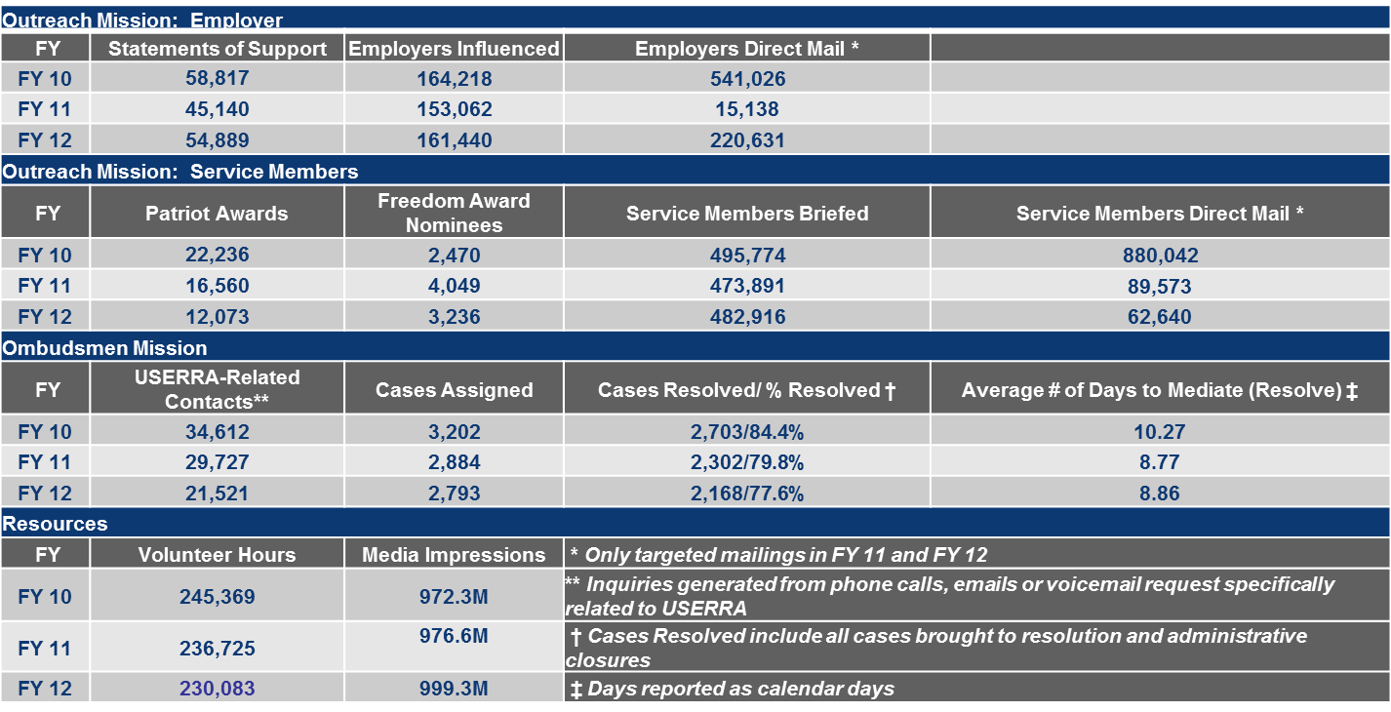
Furthermore, ESGR serves as a member of the USERRA Employment Protection Group established by the Presidential Memorandum dated July 19, 2012, in direct support to the Defense Civilian Personnel Advisory Services (DCPAS) for USERRA expertise. The USERRA Employment Protection Group is comprised of key Federal agencies such as the Office of Personnel Management (OPM), Department of Labor (DOL), Office of Special Counsel (OSC), Department of Defense (DoD) and others. The Presidential Memorandum calls on agencies across the Federal government to intensify their efforts to ensure fair treatment and equal opportunity for veterans and Service members in Federal employment; in particular, the adherence to USERRA that provides critical protections to those who have served our country, including veterans and National Guard and Reserve members.
ESGR directly trained 590 Federal government personnel across 12 different Federal agencies; increasing their knowledge, awareness and compliance with USERRA. ESGR ombudsman volunteers provide assistance to National Guard and Reserve members with USERRA conflicts to help reduce, resolve and prevent employer and/or employee misunderstandings and problems. To ensure robust compliance and timely responses to USERRA matters within the Federal government, all Federal USERRA cases are handled and managed at Headquarters, ESGR Customer Service Center. In FY 12, ESGR mediated 235 Federal government USERRA cases on behalf of Service members.
Latest statistics on the rate of unemployment among Reserve Component Service members: The Status of Forces-Reserve survey from June 2012 reported an unemployment rate of 11% across the Reserve Components, down from 13.1% in the January 2011 survey. At the same time, the junior enlisted Reserve Component Service members self-reported their unemployment rate at 18%, down from 23%. Let me assure you that the Office of the Assistant Secretary of Defense for Reserve Affairs (OASD RA) views civilian employment as a critical piece of a Reserve Component Service member’s readiness, and even though the trend appears to be headed in the right direction, we still see the high rate of unemployment as a threat to the readiness of our force.
Initiatives taken by the Department of Defense to reduce unemployment rates among members of the National Guard and Reserve: To address unemployment among members of the National Guard and Reserve, it is important to note that this is a unique population, as these Service members are not retiring or separating from service. These Service members are still serving, and their future employers must help facilitate their continued participation in our military. . Our goal is to ensure these Service members receive employment assistance responsive to their needs.
Under OASD RA, resources coalesce through the Yellow Ribbon Reintegration Program (YRRP) and ESGR to address the unique employment needs of Reserve Component Service members. The Employment Initiative Program (EIP) is YRRP’s umbrella program for addressing Guard and Reserve employment issues, which leverages ESGR’s nationwide network of more than 4,900 volunteers. DoD also teamed with the VA, DOL-VETS and the Small Business Administration to make resources and valuable training available to Service members. Additionally, ESGR and YRRP continue to cultivate a relationship with the White House’ Joining Forces initiative.
Since the launch of employment initiatives in January 2011, ESGR State Committees across the country have helped Service members and their spouses via employment assistance workshops, job fairs, employment summits, and many other local community programs, teaching resume writing, conducting mock interviews and providing career counseling. In working with the U.S. Chamber of Commerce’s Hiring Our Heroes program, Hero2Hired and ESGR have supported more than 400 hiring fairs across the country, engaging more than 143,000 attendees and resulting in more than 14,000 veterans, Service members, military spouses and wounded warriors gaining employment.
In December 2011, OASD RA launched “Hero2Hired”, better known as H2H. As the marquee element of EIP, H2H is a comprehensive, multi-faceted employment assistance program developed for Reserve Component Service members. Using lessons learned from its piloted use with wounded warriors and the Army Reserve, H2H was created to address the gap in employment assistance services and support for Reserve Component Service members.
H2H is a comprehensive employment assistance program with a powerful job search capability (www.H2H.jobs) and online community that is 100% free for veterans, Service members, and employers. It contains all the tools a job seeker needs to find a job: job listings, career exploration tools, education and training resources, advice and tips, hiring events, virtual career fairs, mobile phone app, and networking opportunities. The goal of H2H is to simplify the job search while reducing the number of unemployed Reserve Component Service members. H2H.jobs also allows military-friendly companies to access the talented men and women who are still serving in the military, post job openings, search for candidates and invite them to apply to a specific job opportunity, and participate in hiring events – all free of charge. In late 2012, Reserve Affairs fielded 56 Employment Transition Coordinators (ETCs) across the Nation, in conjunction with a full-spectrum case management system, enabling our career counselors to provide tailored and personalized support to each and every Service member that seeks career assistance. Since October, ETCs have facilitated the job placement of more than 600 Service members through the H2H program and provided career assistance to thousands more.
As all jobs are local, H2H is a local solution and is well positioned to successfully assist unemployed Reserve Component Service members with job placement, and thereby potentially reducing DoD unemployment costs related to demobilizing Reserve Component members. H2H also assists underemployed Service members by providing access to jobs that match their skill levels and areas of expertise. Using our ETCs, career web platform, mobile applications, social media integration, career fairs, and a national marketing and management effort, H2H is well-positioned as an effective tool to assist our Service members with reintegration and transition. H2H also reduces stress and financial hardships faced by unemployed Reserve Component Service members and their families. Since the program’s launch, more than 108,600 job seekers registered with H2H.jobs, gaining access to over 14,900 employer partners and 3.7 million job postings. In conjunction with our strategic partners, H2H assisted in the placement of over 100,000 Service members into jobs.
Clearly, progress has been made in educating employers and Service members on USERRA while also seeing positive results via a declining unemployment rate among National Guard and Reserve Service members, down from 13.1% to 11%. However, it is imperative that ESGR and YRRP continue educating employers and Service members on USERRA and maintain focus on employment initiatives in order to achieve lasting results. This is especially important in light of the limited resources and leaner forces forecast for the future. The Nation will continue to rely upon a strong National Guard and Reserve forces to execute the national defense strategy and provide humanitarian aid at home and abroad.
In closing, thank you for this opportunity to testify on behalf of everyone that comprises the Family and Employer Programs and Policy Team and most of all, ESGR’s more than 4,900 volunteers located in all 50 States, Washington, D.C., Guam-CNMI, Puerto Rico and the U.S. Virgin Islands. And, thank you for your continued support to our Reserve Component Service members. I look forward to your questions.

