Seth Hanlon
Senior Fellow, Center for American Progress
Testimony before the House Select Committee on Economic Disparities and Fairness in Growth: “Tackling the Tax Code: Evaluating Fairness, Efficiency, and Potential to Spur Inclusive Economic Growth”
June 22, 2022

Chairman Himes, Ranking Member Steil, and Members of the Committee:
Thank you for the opportunity to discuss the critical topic of tax fairness. My testimony today will focus primarily on evaluating tax fairness, in particular how aspects of the federal tax system affect income and wealth inequality.
The first part of my testimony will focus on four major ways in which the existing tax system is unfair and perpetuates economic disparities:
- The federal tax code preferences income from wealth
- The benefit of federal tax expenditures are skewed toward those with higher incomes
- The global “race to the bottom” on corporate taxes and corporate tax avoidance through profit shifting have undermined the U.S. corporate tax base
- Inequitable and inadequate tax enforcement undermines tax fairness
The second part of my testimony focuses on how the budget reconciliation bill passed by the House in November would take large steps toward tax fairness, including by:
- Reforming the corporate international tax system and stopping the race to the bottom
- Rebuilding the Internal Revenue Service (IRS) so that it can better combat sophisticated tax avoidance and evasion by wealthy individuals and corporations and better serve regular taxpayers
- Imposing a surtax on multi-millionaires so that they pay more of their fair share
- Closing the Medicare tax loophole, which allows high-income business owners to avoid paying health care-related taxes that workers and small business owners pay
Last, I will discuss the need for further fundamental reforms that Congress should pursue in the coming years.
At the outset, it is helpful to dissect what we mean by tax fairness. Typically, when it comes to fairness, tax debates focus on two principles – the principle that people with the ability to pay more should pay more (“vertical equity”), and the principle that the tax system should treat people with the same level of financial resources similarly (“horizontal equity”). The ability-to-pay principle generally means that people with higher incomes should pay higher tax rates as a percentage of their incomes. Since income is not the sole measure of ability-to-pay, a fair tax system would reflect the fact that people with large amounts of wealth also have a greater ability to pay. The extreme levels of income and wealth inequality today should also inform considerations of tax fairness: Though the tax code cannot remedy excessive income and wealth inequality on its own, we should expect it to make a meaningful contribution.
Vertical equity and horizontal equity are foundational principles that should guide tax policy. But policymakers must consider at least three other dimensions of fairness.
Recently, there has been a welcome focus on the tax code’s impact on racial and gender equity, which implicate both vertical and horizontal equities. Tax code provisions are virtually always colorblind on their face but can have disparate impacts. Scholars including my co-panelists have emphasized that aspects of the tax code help perpetuate and worsen the racial wealth gap because they favor existing wealth, which is distributed extremely unequally by race due to historical factors – and the income derived from that wealth. Facially neutral tax policies also affect men and women differently, and aspects of the tax code widen gender wealth disparities. A fair tax code would reduce economic disparities along racial, gender, and other demographic lines rather than perpetuate them.
Another dimension of tax fairness that policymakers must not neglect is the need for adequate revenues. A tax system that raises insufficient revenue, leading to underinvestment in public goods and a failure to meet basic human needs, cannot truly be considered a fair tax system, even if it is progressive on its own terms. In fact, a prime reason that the U.S.’s overall fiscal system does relatively less to reduce inequality than those of other comparable countries is that the U.S. raises relatively little revenue – and in turn does relatively little to invest in a host of areas that would reduce gaps in income, mobility, and opportunity, especially by race and gender. These include reducing child poverty, providing child care, and guaranteeing paid family and medical leave.
Finally, tax fairness requires not just a fair tax code, but equitable tax administration. Tax fairness is undermined when people and businesses do not pay the taxes they owe. It is especially corrosive when the wealthy and powerful use their resources to game the tax system. The current system of tax enforcement focuses IRS audits disproportionately on low-income working families even though high-income filers and businesses are responsible for far greater amounts of unpaid taxes, which is not at all fair. It’s also unfair when ordinary taxpayers must pay substantial amounts of money to file their tax returns, or when the IRS cannot provide them with basic levels of service.
With these elements of fairness in mind, I will next discuss four major features of the tax system that exacerbate economic disparities and undermine tax fairness.

Features of the federal tax system that exacerbate economic disparities
The past several decades in the United States have been characterized by increasing income and wealth inequality. The after-tax incomes of the top 0.01 percent grew by 538 percent in real terms between 1979 and 2018, or ten times as fast as the middle 60 percent. The share of wealth owned by the top 0.1 percent more than doubled, from 7 percent to about 18 percent. Various factors are primarily responsible for the rise of inequality, including growing, unchecked corporate concentration; policies that have diminished the power of unions and workers; and flawed trade policies. But one important factor enabling inequality has been how the tax code provides special, favorable tax treatment for income derived from wealth, and utter failing to tax some of the largest fortunes.

The federal tax code’s preference for income from wealth exacerbates inequality
The single biggest failing of the tax code is that the wealthiest people in the United States simply do not pay tax on most of their income from year to year. In fact, billionaires are often able to permanently avoid paying income tax on their massive wealth accumulation, contributing to entrenched inequality across generations.
This failing is built into the structure of the tax code. Under the current income tax, gains on assets are generally not taxed unless and until an asset is sold. As a result, the largest form of economic income for the wealthiest Americans is simply not reported on annual tax returns. Last year, economists Emmanuel Saez and Gabriel Zucman estimated that U.S. billionaires owned $4.25 trillion in wealth – out of which $2.7 trillion consisted of untaxed gains.
As a result, the effective tax rates that billionaires pay – the taxes they pay as a percentage of their income – are often infinitesimal. It may not look that way on their tax returns, since only a small portion of their incomes are reported. But when considering their actual economic incomes, including the appreciation of assets that they continue to hold, their tax rates can be shockingly low. Tax experts, and of course the billionaires themselves, knew this well before ProPublica reported some of the details last year, revealing that the wealthiest 25 people in the United States paid an average “true” tax rate of only 3.4 percent. White House economists, using publicly available statistics, estimated that the Forbes 400 paid an effective tax rate of just 8.2 percent on average from 2010-2018 when considering a comprehensive measure of their income, including realized and unrealized gains. That is less than what many middle-class Americans pay.
The fact that capital gains are not taxed until sold provides a valuable benefit from the deferral of taxes. But perhaps even more significantly, it also provides the wealthiest Americans with a route for avoiding capital gains taxes entirely. Because of the provision known as “stepped-up basis,” if assets are never sold and then passed onto heirs, the gains during a person’s lifetime are erased for income tax purposes. Through debt, billionaires can finance their lifestyle – and their investments and business acquisitions – without having to realize gains.
Thus, some of the largest fortunes in history have never been taxed, and much of them never will be. Former Joint Tax Committee staff director Hank Gutman put it best when he called stepped-up basis “the most glaring loophole in the income tax – the complete exemption of the bulk of the wealth accumulation of the super-rich from income tax.”
Due to existing disparities in wealth and intergenerational wealth transfers, stepped-up basis perpetuates the vast disparities in wealth that exist in the United States, including and especially the Black-white wealth gap.
The tax code also provides several avenues for avoiding or deferring capital gains taxes even when assets are sold. The exemption for Qualified Small Business Stock (QSBS) allows wealthy investors such as Silicon Valley venture capitalists to exclude up to $10 million of gains per individual, but is unavailable for the vast majority of actual small businesses. The tax code allows gains on real estate sales to be deferred through “like-kind exchanges.” And the 2017 tax law introduced a new tax shelter allowing investors to defer and reduce taxes on gains invested in so-called “Opportunity Zones” whether or not the investments produce any economic or social benefits for zone residents.
Moreover, when asset owners do recognize income from capital gains, they are taxed at preferential rates. The top rate on ordinary income is 37 percent while the top rate for long-term capital gains is 20 percent. The low rate for capital gains provides an incentive and often an opportunity for wealthy Americans to avoid taxes by characterizing their income as capital gains. Private equity fund managers, for example, typically structure much of their compensation for managing investor funds as “carried interest,” allowing them to claim the lower rate.
The Tax Cuts and Jobs Act of 2017 (TCJA) added another tax preference for income from wealth with the section 199A deduction. The provision was billed as a “small business” tax cut, but its largest benefits go to the very rich. The deduction effectively exempts from tax up to 20 percent of the income of investors in passthrough businesses such as S-corporations, limited liability companies (LLCs), and partnerships. By introducing this new deduction and reducing the regular top tax rate, TCJA effectively slashed the rate paid by the highest-income business owners and investors from 39.6 percent to 29.6 percent. As with the preferential capital gains rate, the special low rates for passthrough business income invite tax avoidance: For example, CEOs of large companies appear to be exploiting the new deduction to lower their tax rates.

The benefit of tax expenditures is skewed toward higher-income and wealthy households – especially those that ostensibly encourage wealth building
The preferences for capital gains and passthrough businesses are examples of “tax expenditures” – provisions of the tax code that provide special deductions, exemptions, preferential rates, deferrals, or tax credits. The foregone revenue from tax expenditures totaled $1.6 trillion in fiscal year 2019, according to the Congressional Budget Office (CBO), or nearly half (about 46 percent) of total federal revenue that year. If considered its own part of the federal budget, tax expenditures would be the single largest part – larger than the entire discretionary budget, defense and non-defense combined ($1.3 trillion in 2019).
Tax expenditures are therefore a very substantial part of federal fiscal policy. On the whole, their benefits are skewed toward those with higher incomes. Half of the benefit of individual income tax expenditures goes to the highest-income 20 percent. 30 percent of the benefit goes to the top 5 percent. And 19 percent of the benefit goes to the top 1 percent.
Most starkly, the tax incentives that are ostensibly intended to help American families build wealth principally reward those who already have wealth. According to CBO:
- The highest-income 20 percent of Americans receives 95 percent of the benefit of preferential tax rates for capital gains and dividends. The top 1 percent alone receives 75 percent of the benefit.
- The highest-income quintile receives 88 percent of the tax benefit from the new deduction for passthrough business income enacted in the 2017 tax law (section 199A), with the richest 1 percent receiving fully half of the benefit.
- The highest-income quintile receives 56 percent of the benefit from “stepped-up basis” – the provision that wipes out capital gains tax liability when assets are transferred to heirs.
- The top quintile receives 63 percent of the income tax expenditure for retirement savings, while the bottom 60 percent receives only about 13 percent.
- The top quintile receives 84 percent of the benefit of the mortgage interest deduction, while the bottom 60 percent of Americans receive less than 5 percent.
The largest tax expenditure of all are the tax subsidies for private retirement plans, which will cost $380 billion on average over the next five years. That is more than three times the cost of the Earned Income Tax Credit and the refundable portion of the Child Tax Credit combined ($120 billion per year).
As the graphs below from University of Virginia Law Professor Michael Doran illustrate, over recent decades, federal tax subsidies for retirement tax savings have increased considerably. And yet, the benefits of those subsidies have not been broadly shared. The highest-income 10 percent of Americans now have roughly four times as much in their retirement accounts in real terms, while retirement savings for the bottom 80 percent of Americans has hardly increased at all. Doran writes: “Despite hundreds of billions of dollars of increased federal tax subsidies over the past twenty-five years, the retirement security of middle-income earners has remained flat, and the retirement security of lower-income earners has decreased.”
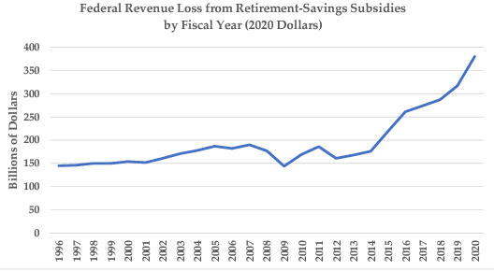
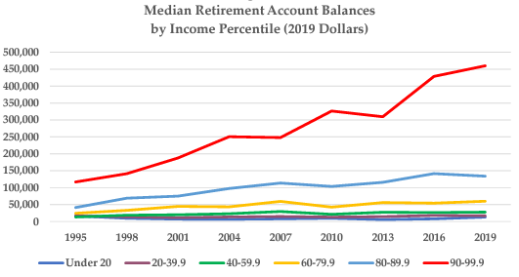
Retirement tax subsidies benefit the already-affluent because of how they are designed. Changes in recent decades have allowed the relatively few people with very large amounts of disposable income to put ever-increasing amounts in tax-favored accounts. In 2020, retirement savings incentives allowed high-income individuals to contribute up to $57,000 per year into a tax-preferred plan, and $63,500 for those older than 50 – both more than the typical full-time worker earned in that year. As the graph below (also from Doran) illustrates, only those with higher incomes can afford to “max out” their tax-preferred retirement accounts. Raising the contribution limits therefore only benefits them.

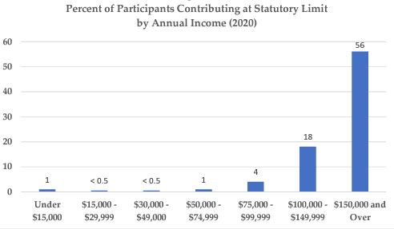

The retirement tax incentives are structured as deductions and exclusions, which means that people in higher tax brackets – higher-income people – derive a larger tax benefit for every dollar contributed to or earned within the accounts (and of course they tend to contribute and accrue more dollars than people in tax brackets below them). Meanwhile, lower-income individuals – who are at much higher risk of retirement insecurity – receive little or no tax benefits if they can afford to contribute to a retirement plan because they tend not to have income tax liability, especially if they have children. There exists a tax credit for retirement savings contributions, but it is nonrefundable – meaning that few low- and moderate-income savers derive any benefit from it.

The form of tax expenditure determines who benefits
- Tax deductions, exclusions, and deferrals tend to disproportionately benefit those with higher incomes, since their value depends on individuals’ tax brackets. The higher tax bracket they are in, the more they benefit. For example, when high-income earners in the 37 percent bracket contribute $1 to a 401(k) plan, they receive $0.37 in tax savings. Meanwhile, every dollar that a middle-income earner in the 12 percent bracket contributes saves them $0.12. A low-income earner with no tax liability receives no tax benefit from contributing to a 401(k).

- Preferential rates tend to favor those with high incomes as well. The passthrough deduction is one example because it effectively provides a 20 percent lower rate. High-income passthrough business owners can reduce their tax rate from 37 percent to 29.6 percent. For moderate-income passthrough business owners, the deduction may reduce their tax rate from 10 percent to 8 percent. The income subject to preferential rates – long-term capital gains, dividends, and qualified passthrough income – is also heavily concentrated toward the top.

- Nonrefundable tax credits provide a flatter tax benefit for people who owe income tax. However, they do not benefit taxpayers who have no income tax liability, millions of whom are low-wage working families with children.

- Refundable tax credits are the only form of tax expenditure that can benefit tax filers regardless of income tax liability. The Earned Income Tax Credit (EITC) is a fully refundable tax credit. The Child Tax Credit (CTC) is partially refundable with certain limits; the American Rescue Plan Act made it fully refundable for 2021 but it has since reverted to its pre-ARPA form.

In sum, tax expenditures for retirement saving are “upside-down”: They direct federal subsidies toward those who need them the least, and where they are least effective.
Existing tax subsidies for retirement savings also widen racial wealth gaps. Black and Hispanic families are significantly less likely to have retirement savings accounts, largely due to unequal workplace access and income disparities. Among those that do have such accounts, white families have average balances nearly triple those of Black and Hispanic families. Women also benefit less from retirement tax subsidies than men because of disparities in income and retirement savings.
The federal subsidies for retirement savings need to be fundamentally overhauled, since the current approach is not working. Unfortunately, pending legislation in Congress, the SECURE 2.0 Act, would magnify some of the subsidies’ existing flaws. The SECURE 2.0 Act would increase the additional contribution limits for individuals over age 60 (so-called “catch-up” contributions) to $10,000 – a provision that would only help those who can afford to put away very large amounts. Another significant provision in the bill would delay the age when retirees are required to take minimum distributions from their 401(k) and IRA plans. My colleague Jean Ross writes that this provision “does nothing for lower-income retirees who depend on their savings to make ends meet while benefiting the wealthy by allowing them to shelter more income for a longer period of time. . . .”
A new Senate retirement tax bill has similar provisions. But it would also replace the existing ineffective saver’s credit with a much better refundable credit that would actually benefit low- and moderate-income savers, albeit not until 2027. The tax credit would be deposited directly into retirement accounts essentially as a federal matching contribution. Given the upside-down nature of retirement incentives, policymakers must focus on reforms such as a refundable savers’ credit before expanding the existing incentives – and should ensure that any reforms have the net effect of reducing disparities in savings and wealth, including by race.

Corporate profit shifting and the international “race to the bottom” on corporate taxes drain revenue
The corporate tax is a highly progressive revenue source because it is borne predominantly by shareholders, who tend to be wealthy. Treasury’s Office of Tax Analysis estimates that about half of the corporate tax is borne by the top 1 percent, and 73 percent by the top 10 percent.
But in recent years, the United States has derived significantly less revenue from the corporate tax than it once did. One major cause of the erosion of the corporate tax is profit shifting – the tactics used by large multinational corporations to avoid paying U.S. tax by artificially reporting billions in global profits in low-tax countries. In 2019, U.S. multinationals reported more than half of their foreign profits in seven tax haven countries. The profits aren’t actually being earned there, as only a very small share of the companies’ employees and physical assets are located in those countries. Rather, the profits are shifted there on paper to avoid taxes. Corporate profit shifting costs the United States an estimated $60 billion per year. (To put that in perspective, the U.S. could double the EITC with that amount of revenue.)
At the same time, countries around the world have engaged in a “race to the bottom” on corporate taxes in recent decades. Countries have reduced their corporate tax rates in response to one another as they fear the loss of both business activity and revenue. The perceived need to compete with other countries on corporate tax rates was a major factor driving the United States to drastically cut its rate from 35 percent to 21 percent in 2017. In the three years after TCJA, the United States raised less revenue from the corporate tax than at any time since the 1930s – barely over 1 percent of GDP. Corporate tax revenues rose sharply in 2021, but that was the result of the large surge in corporate profits.
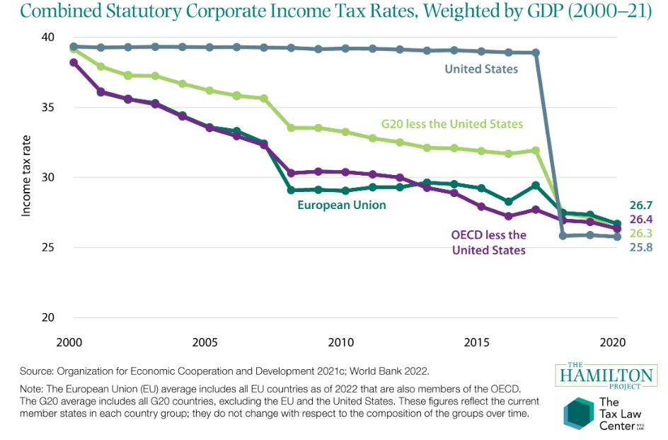
Profit shifting and the corporate race to the bottom have diminished the corporate tax, which is one of the most progressive federal revenue sources. If the U.S. does not raise more revenue from the corporate tax, then to that extent it will have to rely on more regressive revenue sources.
Nations around the world have responded to the corporate race to the bottom by joining a multilateral effort to set a reasonable floor on corporate rates. Last October, the Biden Administration led more than 130 nations in reaching agreement on a 15 percent global corporate minimum tax, known as “OECD Pillar Two.” As discussed below, the United States now has the opportunity to enact a strong corporate overseas minimum tax that would raise revenue, curb profit shifting, and advance the competitiveness of U.S. workers and U.S. investment.

Inequitable and inadequate tax enforcement undermines tax fairness
Tax fairness hinges on both the tax laws and how they are administered and enforced. Recent trends in tax enforcement have made the tax system less equitable. The IRS has been decimated by budget cuts, most harming its ability to ensure that wealthy taxpayers and large corporations pay what they owe. Treasury estimates that the “tax gap” – the difference between taxes owed and taxes paid – will be about $7 trillion over the next decade. Recent research has found that the highest-income 5 percent of taxpayers account for more than half of the tax gap, and that the top 1 percent accounts for 28 percent – or $163 billion per year.
The IRS has lost about 17,000 enforcement personnel over the last decade, most severely reducing its ability to examine complex tax returns such as those filed by large corporations, wealthy taxpayers who often receive income through partnerships, and estates and trusts. Audit rates for millionaires and the largest corporations have plummeted. The IRS has failed to pursue hundreds of thousands of high-income taxpayers who did not even file tax returns. The IRS finds itself outgunned in audits and litigation against wealthy individuals and corporations who are defended by armies of lawyers and accountants.
Perhaps most concerningly for equity, the IRS’s inability to examine complex tax returns has led it to focus a larger share of its resources on the simple tax returns that it can audit easily. It is extraordinarily cheap for the IRS to audit EITC recipients, with the audits done by mail (“correspondence audits”). EITC recipients are audited at three times the rate of all other taxpayers. Given that EITC recipients are disproportionately Black and Hispanic, the recent allocation of IRS enforcement resources has tended to undermine racial equity. There is also evidence that strongly suggests that many families who are denied their tax credits on audit are in fact eligible for them – but simply cannot get through the burdensome audit process, especially because the IRS has too little resources to help filers navigate it. These unfair denials may also fall more heavily on those already experiencing economic exclusion, such as filers with disabilities.
At the same time, the IRS also has less visibility into the kinds of income received by higher-income taxpayers, including partnership and S-corporation income, since much of that income lacks third-party information reporting. By contrast, the IRS has near-perfect visibility into regular workers’ wages, since they are reported by employers on W-2 forms. As a result, virtually all wage income is properly reported, while compliance rates for the forms of income subject to incomplete or no information reporting are dismal. This results in a “two-tiered” system of tax enforcement that undermines tax fairness.

The pending reconciliation bill would take large steps towards tax fairness
Congress now has a golden opportunity to advance tax fairness, and it must seize it. The House-passed budget reconciliation bill for fiscal year 2022 (the “Build Back Better Act”) would raise substantial revenue for investments while making the tax code significantly more progressive.
In so doing, it would reverse much of the damage caused five years ago by TCJA. That law was estimated to cost $1.9 trillion over the following 10 years. And it was heavily weighted toward high-income individuals, who received much bigger tax cuts as a percentage of their (higher) incomes than middle- and low-income families.

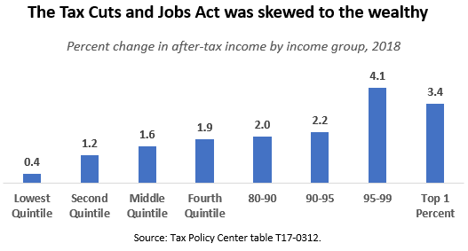

TCJA’s regressivity was driven by several major elements, including:
- Cutting the corporate rate from 35 percent to 21 percent;
- Shifting to a “territorial” system of international taxation with inadequate safeguards against profit shifting;
- Introducing the aforementioned passthrough business deduction, which overwhelmingly benefits high-income business owners and investors;
- Doubling the estate tax exemption, which is now $12 million for individuals and $24 million for couples; and
- Cutting individual rates and scaling back the individual Alternative Minimum Tax.
TCJA also included provisions that offset the regressive effect of the tax cuts – but only partially, as the overall distributional table above shows.
The pending budget reconciliation bill would take the tax code in the opposite direction – toward tax fairness.

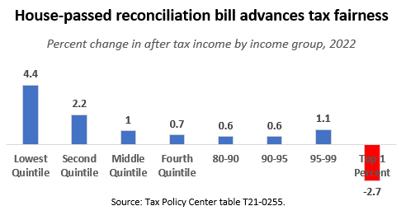
Under the reconciliation bill, the richest 1 percent would pay significantly more in taxes. It would raise nearly $2 trillion in progressive revenue that could be dedicated to investments – or, if Congress chooses, some to deficit reduction. I will highlight four reforms in the bill that are especially important for tax fairness.

Reforming the corporate international tax system and stopping the “race to the bottom”
The House-passed budget reconciliation bill greatly improves the U.S. international tax system. It strengthens the weak overseas minimum tax enacted in TCJA, known as “GILTI” by raising its rate to 15 percent. It applies the minimum tax country-by-country to further reduce opportunities for corporate profit shifting, and broadens the base of income to which the tax applies. These changes would accomplish several goals at once: reducing the differential between foreign and domestic rates, curbing profit shifting, and raising substantial revenue. The House-passed bill also strengthens the provision enacted in TCJA that was aimed at curbing “inbound” profit shifting, known as the “BEAT.” These reforms would substantially align the U.S. international tax system with the OECD agreement, giving further momentum to the multilateral effort to stop the corporate tax race to the bottom. The international tax provisions of the reconciliation bill would raise nearly $300 billion in revenue over ten years according to the Joint Tax Committee. Other major corporate tax provisions in the reconciliation bill – including the 15 percent minimum tax on corporate “book” profits, the 1 percent excise tax on stock buybacks, and other reforms – would raise about $500 billion.

Rebuilding the IRS so that it can better prevent sophisticated tax avoidance and evasion by individuals and corporations and better serve regular taxpayers
The reconciliation bill seizes a rare opportunity to provide the stable, multi-year funding necessary to rebuild and modernize the IRS. The bill includes about $80 billion over the next 10 years, giving the agency the predictability and financial resources to hire new enforcement personnel, upgrade its computer systems, and provide better service to taxpayers. New audit resources will be focused on high-income taxpayers and corporations, where the IRS can recoup the most revenue. Better prioritization of enforcement resources will reverse the disproportionate focus on low-wage workers claiming the EITC, improve racial equity, and help restore basic fairness for honest taxpayers. Treasury’s Office of Tax Analysis estimates that the $80 billion investment will return $480 billion in revenue, mostly by deterring would-be tax cheats. CBO’s estimate is more conservative, but still finds that the investment in the IRS will pay for itself and then some; CBO projects that the $80 billion of funding will return $207 billion in revenue, netting $127 billion.

Imposing a surtax on multi-millionaires
The reconciliation bill would improve the fairness of the tax code by imposing a 5 percent surcharge on the incomes of the richest U.S. households – those with incomes above $10 million—and an additional 3 percent levy on incomes in excess of $25 million. The surcharge would raise an estimated $228 billion in an extremely progressive way – the tax would apply only to the highest-income 0.02 percent of U.S. households, approximately 22,000. Importantly, the surcharge is based on adjusted gross income and allows no special deductions. That means that it would apply to all forms of taxable income (albeit not unrealized gains), including capital gains and “carried interest.” Congress should enact this surcharge without any special carveouts.

Closing the Medicare tax loophole
The reconciliation bill closes a major tax loophole that allows high-income business owners to avoid paying both the Medicare tax that workers and the self-employed pay on their earnings, and the parallel tax that investors pay on unearned income, known as the Net Investment Income tax, or NIIT. Prior to 2010, the Medicare tax applied only to earned income, including self-employment income, but not unearned income. In the Affordable Care Act, Congress addressed this unfairness by enacting the NIIT, a 3.8 percent tax on the investment income received by high-income individuals, including capital gains, dividends, and interest, with the revenue helping to fund expansions of health insurance. (The ACA also effectively raised the Medicare tax from 2.9 percent to 3.8 percent for high-income earners.) However, some forms of business income fell through the cracks between these two taxes. This has meant that some high-income business owners do not pay the tax that other business owners pay, or the Medicare tax that workers pay. The reconciliation bill closes this loophole, leveling the playing field and raising $252 billion in revenue.

More fundamental tax reform is needed to address major sources of tax unfairness
Whether the reconciliation bill passes or not, more fundamental tax reform will be needed to address the root causes of tax unfairness discussed above. Congress will have a window of opportunity to pursue fundamental tax reform over the next few years and the impetus to act with TCJA’s individual tax provisions expiring at the end of 2025. I will make four broad recommendations for reform:
- Implement a Billionaire Minimum Tax
The biggest area where fundamental reform is needed is in the taxation of income from wealth. As discussed above, large amounts of billionaire wealth escape the income tax entirely – a problem that can only be solved with structural reforms to capital gains taxes.
In his fiscal year 2023 budget, President Biden proposes a Billionaire Minimum Income Tax. The proposal ensures that people whose net wealth exceeds $100 million pay an effective tax rate of at least 20 percent on their total income, including unrealized capital gains. It would raise $360 billion in revenue over the next decade and remedy the largest source of unfairness in the tax code. No longer would the ultra-wealthy be able to pay microscopic tax rates on their accumulation of wealth, or avoid income taxes altogether, as they can under the current system.
The President’s proposal is cleverly designed to obviate the need to value non-traded assets on an annual basis, and to permit taxpayers who potentially lack liquidity to defer the tax, with interest due when the tax is ultimately paid. The proposal also accommodates volatility in asset values by spreading out actual tax payments over several years and adjusting liability if assets change in value.
- Repeal TCJA giveaways benefitting the wealthy, especially the passthrough deduction
Congress should let TCJA’s tax cuts for the rich expire at the end of 2025, if it does not repeal them sooner. The most important of these tax cuts to repeal is the passthrough deduction (section 199A), which violates many basic principles of tax fairness. The 199A deduction provides paltry tax cuts, if any, for real small business owners while showering massive benefits on the wealthy. It introduces new sources of complexity and opportunities for tax gaming. It arbitrarily favors those whose income is in the form of business profits rather than wages or salaries, and also favors income from certain professions (architecture, engineering) over others (medicine, law). And it worsens economic disparities by race.
- Overhaul or eliminate upside-down tax expenditures
The fact that many tax expenditures are “upside down” and benefit those who least need the help and the incentive should give policymakers pause before expanding tax expenditures or creating new ones. Policymakers should consider whether the tax code is the ideal vehicle for creating incentives or delivering benefits. In the case of retirement security, for example, policies to bolster Social Security and enhance its benefits are much more effective than any tax incentive. Similarly, Pell Grants are more effective at expanding college access than the various tax incentives for higher education. Rental subsidies, investment in affordable housing, and policies that promote housing supply will increase housing stability and affordability in a much more efficient and equitable way than the mortgage interest deduction.
If Congress does decide to deliver subsidies and benefits through the tax code, it should consider doing so through refundable tax credits to avoid the upside-down effects of deductions and exemptions.
- Expand refundable tax credits including through a permanent, fully refundable child allowance.
The tremendous success of the Child Tax Credit expansion in the American Rescue Plan Act demonstrated the incredible potential of public policies to reduce the United States’ unacceptably high levels of child poverty. The Rescue Act made the CTC fully refundable for the first time, extending its full benefits to the roughly 27 million children who would have otherwise received a partial benefit or none at all. It also increased the amount of the credit and distributed benefits on a monthly basis to help families meet ongoing needs. When monthly CTC payments began to be distributed last July, child poverty and food insufficiency among families with children dropped dramatically and immediately. A permanent, fully refundable tax credit or universally available child benefit would improve the wellbeing and future prospects of American children – one of the best investments the U.S. could make. Last week, Senator Mitt Romney (R-UT) and two colleagues introduced a proposal to turn the Child Tax Credit into a larger monthly child benefit. The proposal is flawed in several ways but it illustrates that there is bipartisan interest in expanding child tax benefits which will hopefully lead to common ground.
There has also been past bipartisan support for expanding the very modest EITC for workers not raising children in their home, which was another key policy enacted temporarily for 2021 in ARPA. The expansion benefitted 17 million low-wage workers, including nearly 6 million people who would otherwise be taxed into or deeper into poverty. It, too, should be made permanent.
* * *
Thank you for the opportunity to submit this testimony today. I look forward to questions and further discussion.

See, e.g., Dorothy A. Brown, The Whiteness of Wealth (2021); Amy Matsui & others, Advancing Gender and Racial Equity by Taxing Wealth (National Women’s Law Center, 2022); William G. Gale, Public Finance and Racism (Brookings Institution, 2021); Chye-Ching Huang & Roderick Taylor, How the Federal Tax Code Can Better Advance Racial Equity (Center on Budget and Policy Priorities, 2019); Carl Davis, Misha Hill & Meg Wiehe, Taxes and Racial Equity: An Overview of State and Local Policy Impacts (Institute for Taxation & Economic Policy, 2021).
See Matsui, ibid; Ariel Jurow Kleiman & others, The Faulty Foundations of the Tax Code (NWLC, 2019).
The United States ranked 32nd out of 38 countries in the Organisation for Economic Cooperation and Development (OECD) in tax revenues as a share of gross domestic product (GDP). Revenues from all levels of government totaled 25.5 percent of U.S. GDP compared to the OECD average of 33.5 percent. OECD Revenue Statistics 2021 – the United States. Figure 4 of Dr. Gale’s testimony illustrates how the United States tax-and-transfer system as a whole reduces income inequality by much less than those of the other countries as measured by the Gini coefficient.
Taxpayers claiming the Earned Income Tax Credit are audited three times more frequently than average. Government Accountability Office, Tax Compliance: Trends of IRS Audit Rates and Results for Individual Taxpayers by Income, GAO-22-104960.
Congressional Budget Office, The Distribution of Household Income, 2018 (2021), exhibits 22 and 23.
Emmanuel Saez & Gabriel Zucman, The Rise of Income and Wealth Inequality in America: Evidence from Distributional Macroeconomic Accounts (NBER Working Paper 27922, Oct. 2020).
Saez & Zucman, How to Get $1 Trillion from 1000 Billionaires: Tax their Gains Now (2021).
Jesse Eisinger, Jeff Ernsthausen & Paul Kiel, The Secret IRS Files: Never-Before-Seen Records Reveal How the Wealthiest Avoid Income Tax, ProPublica (June 8, 2021).
Greg Leiserson & Danny Yagan, What Is the Average Federal Income Tax Rate on the Wealthiest Americans (Sept. 23, 2021).
Seth Hanlon & Nick Buffie, The Forbes 400 Pay Lower Tax Rates Than Many Ordinary Americans (CAP, 2021) (comparing the true tax rates paid by the Forbes 400 to those paid by typical households based on a comprehensive measure of income for both).
Rachel Louise Ensign & Richard Rubin, “Buy, Borrow, Die: How Rich Americans Live Off Their Paper Wealth,” Wall Street Journal (July 13, 2021), https://www.wsj.com/articles/buy-borrow-die-how-rich-americans-live-off-their-paper-wealth-11625909583; Laura Davison & Kaustuv Basu, Elon Musk’s Untaxed Wealth Is Helping to Finance His Twitter Buyout, Bloomberg (April 26, 2022), https://www.bloomberg.com/news/articles/2022-04-26/musk-s-untaxed-wealth-opens-a-path-to-twitter-riling-democrats.
Statement of Harry L. Gutman before the Ways and Means Select Revenue Measures Subcomm. (May 12, 2021).
See Brown, The Whiteness of Wealth.
See Jesse Drucker & Maureen Farrell, A Lavish Tax Dodge for the Ultrawealthy is Easily Multiplied, N.Y. Times, Dec. 28, 2021; Manoj Viswanathan, The Qualified Small Business Stock Exclusion: How Startup Shareholders Get $10 Million (or More) Tax-Free, Columbia Law Review Forum (Vol. 120, 2020).
See Jean Ross, New Research Adds to Evidence That Opportunity Zone Tax Breaks Are Costly and Ineffective (CAP, 2022).
When including the Medicare tax on earnings and the parallel Net Investment Income Tax on capital gains, the top rate for ordinary income is 40.8 percent and the top rate for capital gains is 23.8 percent.
Robert Faturechi & Justin Elliott, How the Trump Tax Law Created a Loophole That Lets Top Executives Net Millions by Slashing Their Own Salaries, ProPublica, Aug. 19, 2021.
CBO, The Distribution of Major Tax Expenditures in 2019 (2021).
Joint Committee on Taxation, Estimates of Federal Tax Expenditures for Fiscal Years 2020-2024 (Nov. 5, 2020); Michael Doran, The Great American Retirement Fraud (SSRN, draft 12/31/21).
Jean Ross, Tax Breaks for Retirement Savings Do Not Help the Workers Who Need Them Most (CAP, 2022).
Because of the saver’s credit’s structure and the lack of access to workplace retirement savings plans among low- and moderate-income workers, the credit is “woefully underutilized,” with only about 3-5 percent of eligible filers claiming it in recent years, and receiving an average benefit of $200. Jennifer Erin Brown & David C. John, Improving the Saver’s Credit for Low- and Moderate-Income Workers (National Institute on Retirement Security, 2017).
See Testimony of Dorothy A. Brown Before the Senate Committee on Finance (April 20, 2021)
Ross, Tax Breaks for Retirement Savings Do Not Help the Workers Who Need Them Most.
See Brittany King, Women More Likely Than Men to Have No Retirement Savings (Census Bureau, 2022); Statement of Monique Morrissey Before the U.S. Department of Labor Advisory Council on Employee Welfare and Pension Benefit Plans (June 25, 2021); Tyler Bond & others, Still Shortchanged (National Institute on Retirement Security (2020); Kleiman, ibid.
H.R. 2954 (117th Congress), sections 107-108. The amount is $5,000 for SIMPLE retirement plans, and catch-up limits are indexed for inflation. The Senate Finance Committee is considering broadly similar legislation this week that would increase the catch-up limits to $10,000 for individuals who are age 60-63. See JCT, Description of the Chairman’s Mark of the “Enhancing American Retirement Now (EARN) Act (June 17, 2022). “A Vanguard Investors survey found that in 2020, just 15 percent of account holders made a catch-up contribution of any size when given the option. . . . Yet of this 15 percent, nearly 6 in 10 account holders with incomes of $150,000 or more made catch-up contributions, while fewer than 1 in 10 individuals with incomes below $150,000 did so. Vanguard also found that 58 percent of those affected by the current contribution limit have incomes of $150,000 or more, and most of these savers already had larger account balances.” Ross, Tax Breaks for Retirement Savings Do Not Help the Workers Who Need Them Most.
Ross, ibid. The Senate bill contains a similar provision.
See JCT, Description of the Chairman’s Mark of the “Enhancing American Retirement Now (EARN) Act (June 17, 2022).
Treasury Office of Tax Analysis, Distribution of Tax Burden, Current Law, 2023 (June 2022).
Wendy Edelberg, Chye-Ching Huang & Rose Jenkins, Six economic facts on international corporate taxation (Brookings, 2022).
William G. Gale, Kyle Pomerleau & Steven M. Rosenthal, The booming economy, not the 2017 tax act, is fueling corporate tax receipts (Brookings Institution, 2022).
Treasury Deputy Assistant Secretary Natasha Sarin, The Case for a Robust Attack on the Tax Gap (Sept. 7, 2021).
For further discussion see Jean Ross, Budget Cuts Are to Blame for Tax Filing Season Challenges (CAP, 2022); Chuck Marr & others, Congress Needs to Take Two Steps to Fund the IRS for the Short and Long Term (CBPP, 2022); U.S. Department of the Treasury, The American Families Plan Tax Compliance Agenda (2021); Seth Hanlon, Unrigging the Economy Will Require Enforcing the Tax Laws (CAP, 2020).
https://www.americanprogress.org/article/bidens-tax-enforcement-overhaul-positive-step-toward-racial-equity/.
See Kathleen Bryant & others, Exclusionary Effects of the IRS Correspondence Audit Process Warrant Further Study (Tax Law Center at NYU Law School & Center for Taxpayer Rights, 2022).
Sarin, ibid.
JCT, Estimated Budget Effects Of The Revenue Provisions Of Title XIII – Committee On Ways And Means, of H.R. 5376, The “Build Back Better Act,” As Reported By The Committee On The Budget, With Modifications (Rules Committee Print 117-18) (Nov. 4, 2021).
Letter from Secretary Janet Yellen to Chairman Richard Neal, Sept. 14, 2021 (attaching a memorandum summarizing OTA’s analysis); CBO, Estimated Revenue Effects of Increased Funding for the Internal Revenue Service in H.R. 5376, the Build Back Better Act (Nov. 18, 2021).
Jean Ross & Seth Hanlon, The Millionaire Surcharge Would Improve the Fairness of the Tax Code (CAP, 2022).
U.S. Department of the Treasury, General Explanations of the Administration’s Fiscal Year 2023 Revenue Proposals (March 2022).
Marco Guzman, The One Thing Missing From the Qualified Business Income Deduction Conversation: Racial Equity (ITEP, 2021).
See Lily L. Batchelder, Fred T. Goldberg, Jr. & Peter R. Orszag, Efficiency and Tax Incentives: The Case for Refundable Tax Credits, 59 Stanford Law Review 23 (2006).
The Rescue Act’s CTC expansion was modeled on the American Family Act, the House version of which is H.R. 928, Reps. DeLauro, DelBene, and Torres. For further discussion of the dramatic effects of the 2021 CTC expansion, see Testimony of Sharon Parrott Before the House Committee on the Budget (CBPP, June 14, 2022); Kyle Ross & others, The ARP Grew the Economy, Reduced Poverty, and Eased Financial Hardship for Millions (CAP, 2022).
The Family Security Act 2.0 (Sens. Romney, Burr & Daines). Senator Romney’s new proposal would only make the full child benefit available to families with at least $10,000 of earnings. In that respect, it is a significant improvement over current law but would not reduce child poverty by nearly as much as a fully refundable credit. The “offsets,” including reductions in the Earned Income Tax Credit, would reduce the benefit for many families. Many families would be made worse off on net from the elimination of the head of household tax filing status and the child tax credit for families in which the children have Social Security Numbers but parents do not.
Chuck Marr, Another Tax Day Message for Congress: Time to Expand EITC for Adults Without Children (CBPP, 2022).

